**Engineering electromagnetics - Experiment 1**

1. **Objectives:**
2. Get familiar with the electric field distributions of single and multiple point charges in the vacuum.
3. Calculate the distribution of electric field and plot the relevant figures through Matlab.
4. **Related knowledge:**

In vacuum, the electric field intensity (**E**) of a point charge can be expressed as:

E =  (1)

Where the coefficient k = 9 ×  is the electrostatic constant. Q represents the total amount of charge. R denotes the distance between the point in the electric field and the source charge.

If we take the reference point as the infinite distance, then the electric potential at a point in the field is expressed as:

 (2)

The electric field intensity can be expressed as the negtive gradient of the electric potential

$E=-∇V$ (3)

The electric field generated by N point charge in the vacuum is expressed as:

 (4)

Similarly, the field magnitude generated by N point charges in the vacuum can be obtained through equation (3).

Matlab is a word combining with Matrix and Laboratory, it means matrix laboratory. It is a highly efficient computation platform developed by an American company i.e. Mathworks. This software is capable of dealing with problems of scientific calculation, visualization and interactive program design. It integrates many powerful functions including numerical analysis, matrix computation, data visualization, modeling and simulation of nonlinear dynamic systems into an easy-to-use window environment. It provides a comprehensive solution for scientific research, engineering design and a number of scientific areas where effective numerical calculation are required. To a great extent, it gets rid of the traditional non-interactive editing mode that is adopted by several programming languages (e.g. C, Fortan, etc). An example of analyzing the electric field generated by a point charge through MATLAB is illustrated in the following.

The problem is based on a two-dimensional rectangular coordinate system, assuming that there is a point charge at the origin of the coordinates with Q = 110-9 C. The range of the studied electric field is x=[-0.05, 0.05], y=[-0.05, 0.05] （unit：m）

1. Calculate and plot the potential distribution of each point in the field;
2. Plot the distribution of potential lines in the field;
3. Plot the distribution of equipotential lines and streamlines (expressed by smooth continuous curves) in the field;
4. Plot the distribution of potential lines and streamlines (expressed by normalized arrows) in the field.

The code is listed below:

clear; % clear all variables in memory

clc; % Clear the contents of the command window

k=9e9; % set electrostatic constant

Q=1e-9; % Set charge Q

xm=0.05; % Set the range of the field in x direction

ym=0.05; % Set the range of the field in y direction

x=linspace(-xm,xm,20); % evenly divide the x axis into 20 segments

y=linspace(-ym,ym,20); % evenly divide the y axis into 20 segments

[X,Y]=meshgrid(x,y); % To form the coordinates of each point in the field.

R=sqrt(X.^2+Y.^2); % calculate the distance between each point and the source charge (the origin).

V=k*Q./R; % calculate the electric potential of each point

mesh(X,Y,V); % plot the distribution of electric potential

hold on;

title(‘the plot of electric potential distribution of a point charge in the vacuum’, ‘fontsize’,20);

% The title for the plot(Note that all symbols should be half-angled English characters )

xlabel(‘X axis(unit: m)’,‘fontsize’,20); % label the x axis

ylabel(‘Y轴(单位: m)’,‘fontsize’,20); % label the y axis

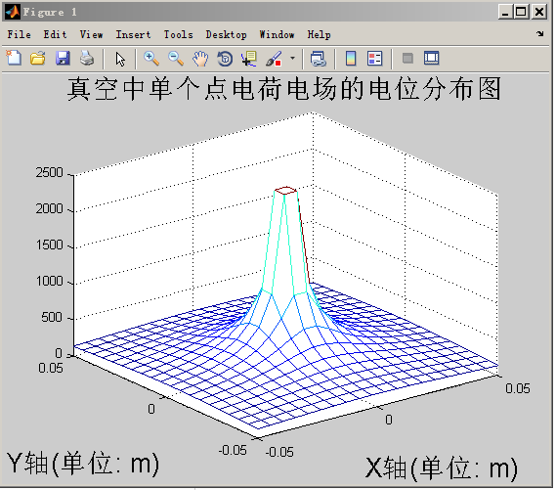

**（Remember to close the last plot window）**

Vmin=200; % set the minimum potential value for a family of equipotential lines

Vmax=2000; % set the minimum potential value for a family of equipotential lines

Veq=linspace(Vmin,Vmax,10); % set the potential for 10 equipotential lines

contour(X,Y,V,Veq); % plot 10 equipotential lines

grid on % form a grid

hold on % hold the plot

plot(0,0,'o', 'MarkerSize',12) % plot a charge at the origin

title(‘Isopotential Line of single Point charge Electric Field in vacuum’, ‘fontsize’, 20);

% title the plot

xlabel(‘X axis(unit: m)’, ‘fontsize’, 20); % label the x axis

ylabel(‘Y axis(unit: m)’, ‘fontsize’, 20); % label the y axis

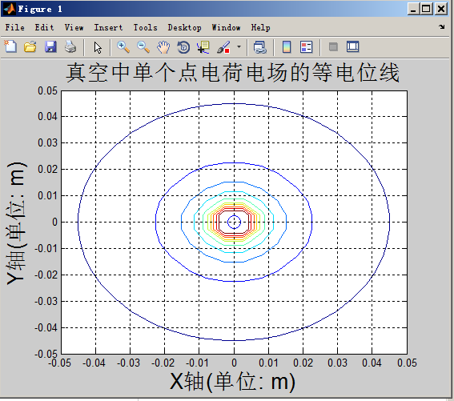

(remember to close the plot window )

[Ex,Ey]=gradient(-V); % Calculation of two components of Electric Field intensity at each Point in the Field

del_theta=20; % Set the angle difference between adjacent field lines;

theta=(0:del_theta:360).*pi/180; % express the angle into radian；

xs=0.004*cos(theta); % generate the x coordinate for the start of the field line；

ys=0.004*sin(theta); % generate the x coordinate for the start of the field line；

streamline(X,Y,Ex,Ey,xs,ys) % generate the field lines；

grid on % from the grid

hold on % hold the plot

contour(X,Y,V,Veq); % plot 10 equipotential lines

plot(0,0,'o', 'MarkerSize',12) % plot the point charge at the origin

title(‘Isopotential Line and Power Line of a single Point charge Electric Field in vacuum (expressed by smooth continuous Curves ’, ‘fontsize’,12) % title the plot

xlabel(‘X axis(unit: m)’, ‘fontsize’, 12); % label the x axis

ylabel(‘Y axis (unit: m)’, ‘fontsize’, 12); % label the y axis

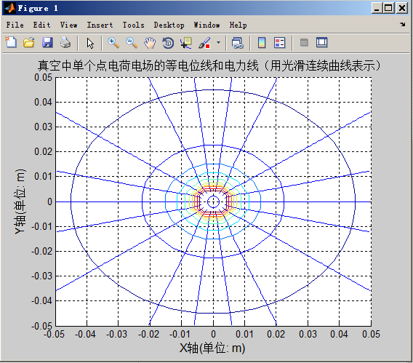

**(Remember to close the previous plot window)**

E=sqrt(Ex.^2+Ey.^2); % calculate the magnitude of electric field magnitude at each point.

Ex=Ex./E;

Ey=Ey./E; % normalize the magnitude of the electric field

quiver(X,Y,Ex,Ey); % using normalized arrowhead to represent electric field

hold on;

contour(X,Y,V,Veq); % plot the equipotential lines

title(‘Equipotential lines and electric field lines of a single point charge electric field in vacuum

（represented by normalized arrowhead）’, ‘fontsize’, 12);

% title the graph

xlabel(‘X axis(unit: m)’, ‘fontsize’, 12); % label the X axis

ylabel(‘Y axis(unit: m)’, ‘fontsize’, 12); % label the Y axis

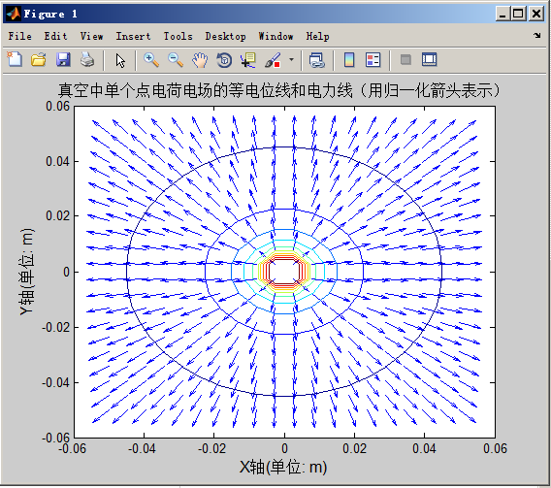

1. **Experiment Content**

Analyze the distribution of electric field throght MATLAB for the following 3 conditions:

1. Point charge Q1= 110-9 C lies at P1[-0.01,0]，point charge Q2= 110-9C, lies at P2[0.01,0];
2. Point charge Q1= 510-9 C lies at P1[-2,0]，point charge Q2= -510-9 C, lies at P2[2,0];
3. Point charge Q1= 810-9 C lie as point P1[-sqrt(3),-1]，point charge Q2= 810-9C, lies at P2[sqrt(3),-1], point charge Q3= 810-9 C lies as point P1[0,2];

**Requirements:**

1. For each case, select the appropriate field range;
2. Calculate and plot the potential distribution of each point in the field.
3. Plot the distribution of the contours in the field (select the appropriate equipotential values according to the actual situation)
4. Plot the distribution of equipotential lines and steamlines in the field (represented by smooth continuous curves) in the field;
5. Plot the distribution of equipotential lines and steamlines in the field.(represented by normalized arrowheads)
6. Name and student ID should be included in the title of each figure
7. Outline for the Lab reports:

**Engineering Electromagnetics - Experiment 1**

Name:*** Student ID:***

1. Case 1:Electric field distribution of two identical point charges;
2. Matlab source code. (remember to illustrate your code)
3. Experiment results(show the generated graphs and brief analysis)
4. Case 2: Electric field distribution of two opposite point charges with the same magnitude;
5. Matlab source code. (remember to illustrate your code)
6. Experiment results(show the generated graphs and brief analysis)
7. Case 3: Electric Field Distribution of three identical point charges located at the vertices of an equilateral triangle;
8. Matlab source code. (remember to illustrate your code)
9. Experiment results(show the generated graphs and brief analysis)
10. Briefly state what you have learned or your particular findings through the experiment.